Presentation Skills Checklist Name: ________________________

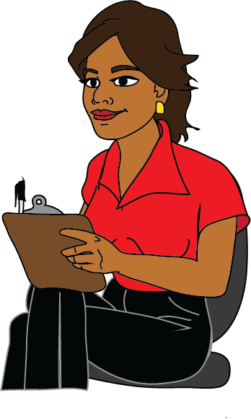
Teacher Note: Feel free to delete or modify any part of the handout to meet your students’ needs.
~ Teacher Responsibilities ~
- I will give you a checklist of specific skills I want you to demonstrate and provide time to practice those skills before your actual presentation.
- During your presentations, I will model how to be an active listener.
- I will ask good questions at the end of each presentation and expect you to do the same.
- I will help you pay attention to other students’ presentations and not interrupt/distract them.
- I will give you brief praise and advice (in the checklist’s feedback sections) after your presentation.

~ Student Responsibilities ~
When you’re speaking to an audience, it’s not just what you say, it’s how you say it! These guidelines will help you inform and persuade your listeners.

1. At the start of your presentation, formally greet your audience (Good morning/afternoon or Hello, class) and introduce yourself and your group members (My name is ____, and this is ____, ____, and ____ ).
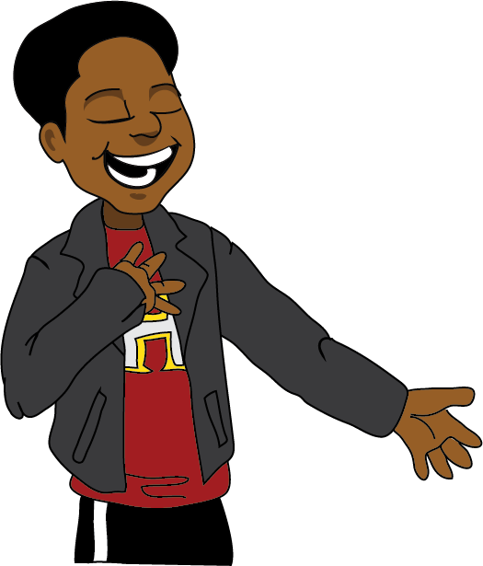
- I practiced with a peer / at home
- I practiced with the teacher
-------------------------------------------------------------------
Teacher feedback on my presentation
1 2 3 4
Keep practicing Nailed it

2. When you speak, face your audience squarely and make eye contact with them. You can glance at your poster or slides from time to time, but don’t read them out to your listeners.
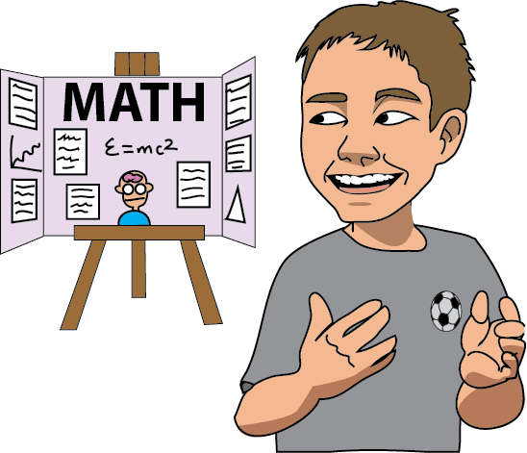
- I practiced with a peer / at home
- I practiced with the teacher
-------------------------------------------------------------------
Teacher feedback on my presentation
1 2 3 4
Keep practicing Nailed it

3. Project your voice so that everyone in the room can hear you.
- I practiced with a peer / at home
- I practiced with the teacher
-------------------------------------------------------------------
Teacher feedback on my presentation
1 2 3 4
Keep practicing Nailed it
4. Be engaged in the presentation. It models the right behavior for your audience, and it makes you ready to help out your group members if any of them forgets what to say while they’re speaking.
- I practiced with a peer / at home
- I practiced with the teacher
-------------------------------------------------------------------
Teacher feedback on my presentation
1 2 3 4
Keep practicing Nailed it

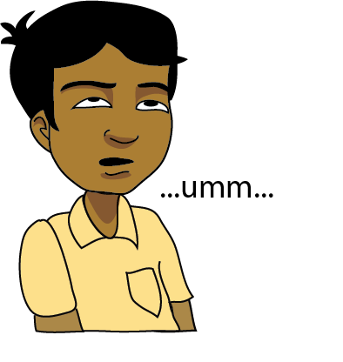
5. Speak clearly and avoid filler words (um, yeah, like, and stuff).
- I practiced with a peer / at home
- I practiced with the teacher
-------------------------------------------------------------------
Teacher feedback on my presentation
1 2 3 4
Keep practicing Nailed it

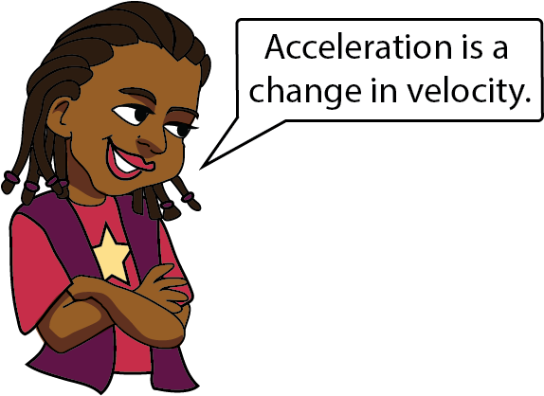
6. Speak intelligently about your topic by explaining important concepts with accurate vocabulary and logical organization.
- I practiced with a peer / at home
- I practiced with the teacher
-------------------------------------------------------------------
Teacher feedback on my presentation
1 2 3 4
Keep practicing Nailed it

7. Give credit to your fellow group members’ contributions.
- I practiced with a peer / at home
- I practiced with the teacher
-------------------------------------------------------------------
Teacher feedback on my presentation
1 2 3 4
Keep practicing Nailed it

8. At the end of your group’s presentation, thank the audience for listening.
- I practiced with a peer / at home
- I practiced with the teacher
-------------------------------------------------------------------
Teacher feedback on my presentation
1 2 3 4
Keep practicing Nailed it

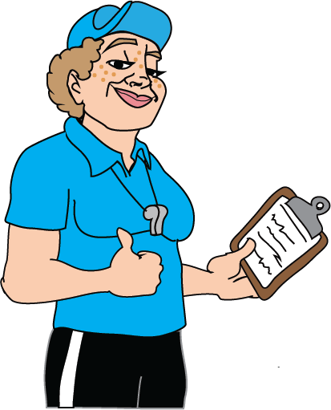
Coach says: “Wanna do something right in the game? Do it right a dozen times in practice.”

