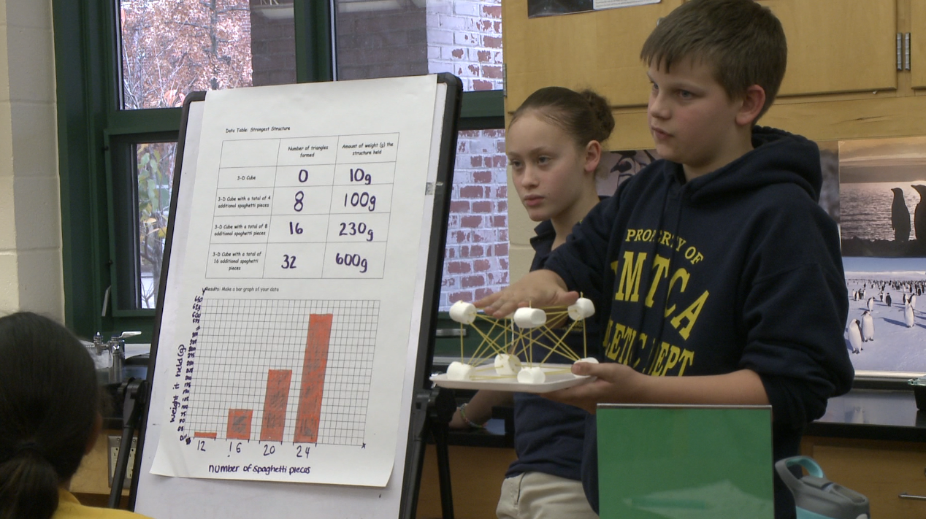
Project-Based Learning Level 1
Evidence 2

Your Name: ________________________________

Integrate elements of PBL Level 1 in your planning and teaching

Note: To provide evidence, you may enter text and embed images into this Word document as well as upload separate files using the corresponding buttons in each section.

A. Create a project plan that integrates the four PBL Level 1 elements below and includes at least one success criteria rubric. Use either the provided project plan and rubric or your own planning template.
- Teacher aligns project to required learning standards.
- Students have some voice and choice in how they approach the project.
- Teacher provides guidance through grouping, circulation, scheduling, questioning, and feedback.
- Students create a product or solution and present it to an audience.

B. Implement the project in your class. During the project, collect at least four pieces of evidence of PBL Level 1 elements in action. Insert and briefly explain how each piece of evidence demonstrates one or more of the elements. Consider the following types of evidence:
- Printed materials like student schedules, grouping arrangements, design drafts, feedback, and checklists; completed teacher observation forms from admins/colleagues
- Photos/Video of students working (upload videos to YouTube and include links in the rationale)

C. Insert print/photo/video evidence of at least two completed projects (can be the same project done by different student groups). Also, include a copy of an assessed rubric for each project with annotations about how the project met certain criteria and did not meet others.

D. Write an overall reflection of the project explaining what worked and why, what didn’t work and why not, and what you will improve for next time. (Up to 300 words.)

A. Complete the following project plan template, or replace it with your own project plan:

Project title:
Standards addressed:
(Code / Description)
Anticipated project duration
(In days, periods, etc.)
Objective(s):

How will students exercise voice and choice?
Formative assessment(s):
How will you measure student learning during project?
Lesson materials and resources:

Project outline:
List each step that teacher/ students take during the project. Must include student presentation.
How will you differentiate instruction for students approaching and students exceeding mastery?
What management strategies will you use during the project?
Additional information:

Complete this rubric (or replace it with a rubric you’ve already created) so it includes at least three criteria for how students will demonstrate success with the project.

Criteria | Approaching Mastery | Mastery | Exceeds Mastery

B. Insert at least four pieces of PBL Level 1 evidence here and explain how each demonstrates one or more PBL Level 1 elements:

C. Insert evidence of two completed projects and their corresponding rubrics here:

D. Enter overall reflection here (up to 300 words):

